Radiocommunication Study Groups
Received: 4 May 2022  Source: Document 4A/522 (Annex 14)  Subject: Small Satellite Handbook | Document 4A/665-E
 | 5 May 2022
 | English only
Saudi Arabia (Kingdom of)
KSU_CUBESAT satellite inclusion in woRKING DOCUMENT ON DEVELOPING AN ITU-R SMALL SATELLITE HANDBOOK
The administration of Saudi Arabia would like to submit this contribution in support of the development of the Small Satellite Handbook. The contribution proposes the addition of Section 5.2.2 to the working draft of the handbook from the October 2021 meeting of WP 4A (Doc. 4A/522 Annex 14).
The KSU_CUBESAT satellite is the first 1-U launched by King Saud University in Saudi Arabia. The satellite was built and developed by the College of Engineering students with the aim of preparing and training engineering students at the university in the field of designing and programming satellites in line with the Kingdom’s vision 2030. The specific objective of the CubeSat is sending telemetry and images by a small camera from space and repeating a received voice.
Due to the size of the Draft Small Satellite Handbook, we have only added Section 5.2.2 in the attachment to this contribution, which should eventually be added in Section 5.2 (Education Missions) of the handbook (Doc. 4A/522, Annex 14) during the next meeting of WP 4A, as appropriate.
Attachment: 1

Attachment
Draft Small Satellite Handbook
…

5 Types of missions

5.2 Education Missions

5.2.2 KSU_CUBESAT
The KSU_CUBESAT satellite is the first 1-U launched by King Saud University in Saudi Arabia. The satellite was built and developed by the College of Engineering students with the aim of preparing and training engineering students at the university in the field of designing and programming satellites in line with the Kingdom’s vision 2030. The specific objective of the CubeSat is sending telemetry and images by a small camera from space and repeating a received voice signal.
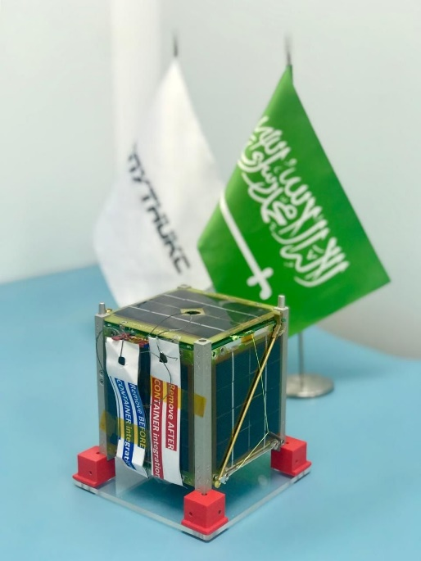
The satellite was launched on March 22, 2021, by the Soyuz Rocket from the Tyuratam Missile and Space Centre, Kazakhstan in collaboration with Saudi Arabia and the Aerospace Capital (12U deployer). The KSU_CUBESAT is also known by its Norad ID 47954 or the international designation (CO SPAR) 2021-022Y. The satellite orbits with an altitude of 550 km and an inclination of 97.6˚, at a speed of 27,000-28,000 km/h and can easily pick up its signal in the Kingdom within 7-12 minutes. The lifespan for the KSU_CUBESAT is expected to be 24 months.
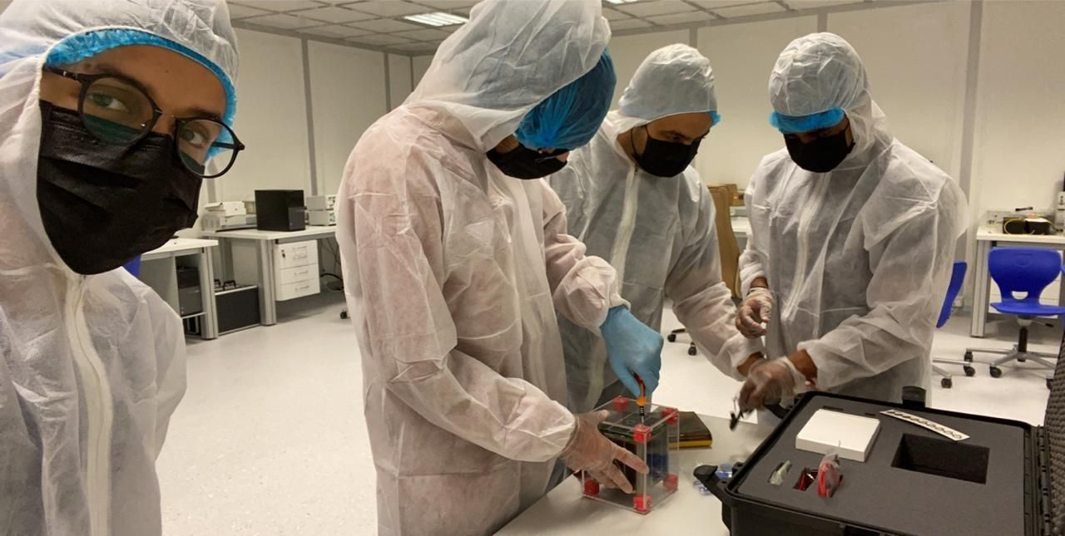
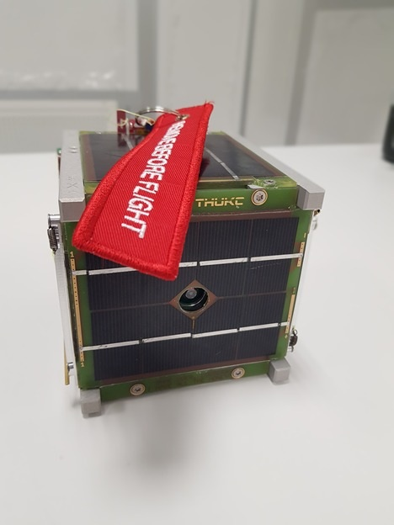

The design of the KSU_CUBESAT includes various Commercial Off the Shelf Components (COTS) and a custom Printed Circuit Board (PCB) for the camera and the transmitter as the payload. The Cube Sat is equipped with a commercial ARM processor for the On-Board Computer. It measures 0.1x0.1x0.1 m and weighs 1 kg. The communication system has a UHF transmitter (Mode U - GMSK4k8 AX.25) operating on a downlink band of 437.130 MHz, at a speed of 4800 bps. Moreover, the UHF Antenna System consists of RF Splitter and 4 monopole antennae, with a typical peak gain of 37dB delivering a maximum RF power of 10W. The camera in the system is a 0.3 pixel and weighs 0.4kg (similar to other 1U CubeSats).
References:
[1] Krebs, Gunter D. “KSU-Cubesat”. Gunter's Space Page. Retrieved April 27, 2022, from https://space.skyrocket.de/doc_sdat/ksu-cubesat.htm
[2] Kulu Eric “Database nanosats.eu”. Retrieved April26,2022, from https://airtable.com/shrafcwXODMMKeRgU/tbldJoOBP5wlNOJQY/viwrecgNj5pECsxOs/recTw7boWSMy8ti2H
[3] Dominic Ford “KSU-CUBESAT” Retrieved April 27,2022 from https://in-the-sky.org/spacecraft.php?id=47954
[4] Fredy “ SatNOGS DB” Retrieved April 27th ,2022 https://db.satnogs.org/satellite/99720#transmitters
[5] “IARU Amateur Satellite Frequency Coordination” Retrieved April 26,2022 from http://www.amsatuk.me.uk/iaru/finished_detail.php?serialnum=722
[6] “ Saudi Arabia Launches Two Satellites for KACST and KSU” Retrieved April 26,2022 from https://www.spa.gov.sa/2205334
[7] “King Saud University signals go-ahead for second satellite” Retrieved April 26,2022 from https://www.arabnews.com/node/1836141/saudi-arabia
_______________

