Radiocommunication Study Groups
Received: 14 February 2022 | Document 6-1/101-E
 | 15 February 2022
 | English only
Saudi Arabia (Kingdom of), United Arab Emirates
Proposals for Modifications of Working document on Review of the spectrum use and the study on spectrum needs of existing services within the frequency band 470-960 MHz in Region 1, in particular the spectrum requirements of the broadcasting and mobile, except aeronautical mobile, services, taking into account the relevant ITU Radiocommunication Sector (ITU-R) studies, Recommendations and Reports

Introduction
Resolution 235 (WRC-15) calls for review of the spectrum use and needs within the frequency band 470-960 MHz in Region 1, and to take appropriate regulatory actions including potential allocation to mobile service and/or identification of IMT within the whole band, or parts thereof.

Proposal
The co-signing Administrations propose the following modifications to the draft CPM text as provided in the attachment to be included in the “Working Document towards Review of the spectrum use and the study on spectrum needs of existing services within the frequency band 470-960 MHz in Region 1, in particular the spectrum requirements of the broadcasting and mobile, except aeronautical mobile, services, taking into account the relevant ITU Radiocommunication Sector (ITU-R) studies, Recommendations and Reports” in preparation for WRC-23 agenda item (AI) 1.5 (Annex 1 to Document 6-1/77).
Attachment: 1

ATTACHMENT
Proposals for Modifications of Working document on Review of the spectrum use and the study on spectrum needs of existing services within the frequency band 470-960 MHz in Region 1, in particular the spectrum requirements of the broadcasting and mobile, except aeronautical mobile, services, taking into account the relevant ITU Radiocommunication Sector (ITU-R) studies, Recommendations and Reports
…

3 Spectrum use within the frequency band 470-960 MHz, in conformity with the Radio Regulations and taking into account GE06 Agreement as stipulated in the recognising a), b), and c) of the Resolution 235 (WRC-15)

3.1 Spectrum use of the broadcasting service
…
With the switch to digital in many areas within Region 1, though not all, broadcast services have been successively moved out of the 790-862 MHz band (“800 MHz band”) and the 694-790 MHz band (“700 MHz band”).

{Editor's note: There is discussion on whether or not/how to refer to the Report ITU-R BT.2302 taking into account the concerns of some Administrations to its content. There is a need to describe the concerns of some Administrations regarding its content.}]
[Fuller information on the current spectrum use by the broadcasting service in the frequency band 470-960 MHz in Region 1 is given in the most recent version of Report ITU-R BT.2302.]

3.1.1 Regional trends in the spectrum use of the broadcasting service
According to a recent study on the “Future use of UHF spectrum in ITU Region 1”, the introduction of digital terrestrial television and Analog Switch-Off (ASO) in many countries in Region 1 has enabled more efficient spectrum utilization for the delivery of terrestrial television broadcast services, in terms of HD quality and number of utilizable channels. Furthermore, in 2008, the DVB-T2 standard was launched, which allowed for even greater spectral efficiency over DVB-T by around 60%, given its higher modulation schemes, additional OFDM modes and new error correction methods (e.g. a single DTT multiplex using DVB-T2 and H.265 coding can support up to 6 HD channels). It should also be observed that the majority of countries in Region 1 have DVB-T2 capabilities, as indicated in the table below.
Table 1
DTT standards deployed in Region 1
DVB-T Only | DVB-T2 Only | DVB-T & T2 | ISDB-T | Unclear
18% | 45% | 25% | 2% | 10%

The number of national DTT multiplexes (mux) deployed or planned in the UHF band typically ranges from one to six. The table below provides a breakdown of the number of national muxes in the UHF band in Region 1, based on the responses from national administrations to the ITU’s 2020 questionnaire on broadcasting. Several countries including many of those in the Middle East have a reduced average number of DTT services as well. Furthermore, more than half of Region 1 countries have less than 10 national and 10 regional DTT services, as shown in the following tables.
Table 2
Number of national DTT muxes in 470–694 MHz
Number of Muxes | 0 | 1-3 | 4-6 | 7-10 | >10
Number of Countries | 1 | 19 | ~42 | 9 | 6

Table 3
Number of national DTT muxes in 470–694 MHz
Number | 0 | 1-10 | 11-20 | 21-30 | >30
National DTT Services | 3% | 51% | 28% | 9% | 9%
Regional DTT Services | 29% | 32% | 15% | 4% | 20%

DTT systems are one of several methods of delivering audio-visual services, and given the increasing adoption among users of the alternative solutions and systems including OTT and other broadcasting solutions, there is proportionately a decrease in the number of DTT service users. Also, DTT has several disadvantages compared to other methods of audio-visual delivery, such as reduced number of channels and limited user content selection. As such, there is a growing trend away from linear viewing in general, such as satellite and DTT, compared to other methods of television viewing and online services which are delivered directly to users with improved performance. In general, linear and less flexible services are losing popularity compared to other technologies which have evolved to support user demands for variability.

3.2 Spectrum use of the mobile service (except aeronautical mobile)
Based on information supplied by WP 5A, WP 5D and WP 6A, the following mobile service applications are using the band 470-960 MHz within Region 1:
– IMT
{Editor’s note: It was suggested that it could be further clarified that the IMT information below addresses IMT as an application of the mobile service and not IMT as a technology.}
– Services Ancillary to Broadcasting/Services Ancillary to Programme-Making
– PPDR (including broadband PPDR in accordance with Resolution 646 (WRC-19))
– Non IMT trunked ad hoc systems
– Railway Communications
– Private Mobile Radio (PMR)
– Devices using temporarily unused/unoccupied spectrum
– Short-Range Device
– Other non-IMT mobile applications.
These applications are considered further in the sub-sections below and/or in the Annexes, based on responses to Administrative Circular CACE/963 on “Spectrum use and spectrum needs of the IMT applications/systems in mobile (except aeronautical mobile) service within the frequency band 470-960 MHz in Region 1” and Administrative Circular CACE/966 on “Spectrum use and spectrum needs of non-IMT applications/systems of the land mobile service within the frequency band 470-960 MHz in Region 1” which invited Administrations of Region 1 to submit input contributions on their spectrum use for the mobile (except aeronautical mobile) service within the frequency band 470-960 MHz. The Responses are contained in Annexes B and C to this document.
...

4 Spectrum needs within the frequency band 470-960 MHz in Region 1, taking into account GE06 Agreement as stipulated in the recognising a), b), and c) of the Resolution 235 (WRC-15)

4.1 Spectrum needs of the broadcasting service
The 470-862 MHz band is the [only] spectrum allocated for broadcasting service for terrestrial television applications across all Regions.
The 470-862 MHz band, or parts thereof, [may still be/is still] needed for broadcasting service for terrestrial television in [some countries in] Region 1 (see section 4.1.2) [noting that some other countries do not need this band for terrestrial television in traditional linear transmission.]
{Editor's note: In some countries this spectrum is no more used for broadcasting and it has to be taken into account somewhere in the text}
Broadcasting serves an important social function. Historically, all television delivery was by terrestrial means. The delivery mechanisms in place have evolved in subsequent decades and have also diverged (e.g. online streaming). In some countries, delivery via cable systems or satellite has come to dominate, while in others terrestrial delivery remains dominant.
In Region 1 and in Iran, Geneva 2006 Agreement (“GE06”) applies for the band 470-862 MHz. It recognizes three distinct reception conditions for digital television: fixed, portable outdoor (mobile) and portable indoor. While cable or satellite delivery are suitable for fixed reception, only terrestrial delivery can be used in portable, mobile and fixed reception scenarios. There are also significant differences in different geographical or regional areas because of different penetration of fixed, satellite and terrestrial services.
Terrestrial broadcasting transmission ensures cost effective delivery of common information such as entertainment and news, often in high-definition format, assuming that some people are interested in viewing the same content at the same time.
To continue to support the social value of broadcasting services, it will be necessary to consider the needs and preferences of the public as to the ways and means by which they consume audiovisual content by relevant communication technologies when deciding to make an appropriate amount of frequency resource available for digital terrestrial TV broadcasting service.
Various future trends can be identified that could have an impact on future demand for broadcast spectrum, as shown in the sections below. The applicability of these will vary from country to country.
According to a recent study on the future use of UHF spectrum in ITU Region 1, there is a trend of declining usage of DTT in the UHF band, with a number of countries having reduced their number of multiplexes to a single multiplex, while others have switched off their DTT services entirely. Furthermore, the share of the population which is reached by DTT services is also reducing in some countries as well, down to as low as single digit percentages.
Besides the variation in the number of DTT services available in each country, there is also some variation in the estimation of requirements for spectrum in the band as well, where several countries indicated that the amount of spectrum currently available for DTT services is exceeding the requirements of the service. Some countries also have very few broadcast channels, which would lead to significant inefficiency if the amount of spectrum available is above the needs of the services. Several countries have also not responded to the questionnaire, and their requirements are unclear as of now.
In a recent study on the Arab region spectrum use and needs in the UHF band, including below 694 MHz, an examination of the spectrum requirements of existing TV services (with consideration of upgrades from SD to HD) found that an estimated 1 to 4 muxes would be required to satisfy the needs, as shown in the figure below. This indicates that, given the significant amount of surplus spectrum which would be available, there is potential for improving the spectral efficiency and utilization of the band, and that future DTT needs could be accommodated with less spectrum than is currently available to the service.
Figure 1
Estimated spectrum requirements for DTT in the Arab region
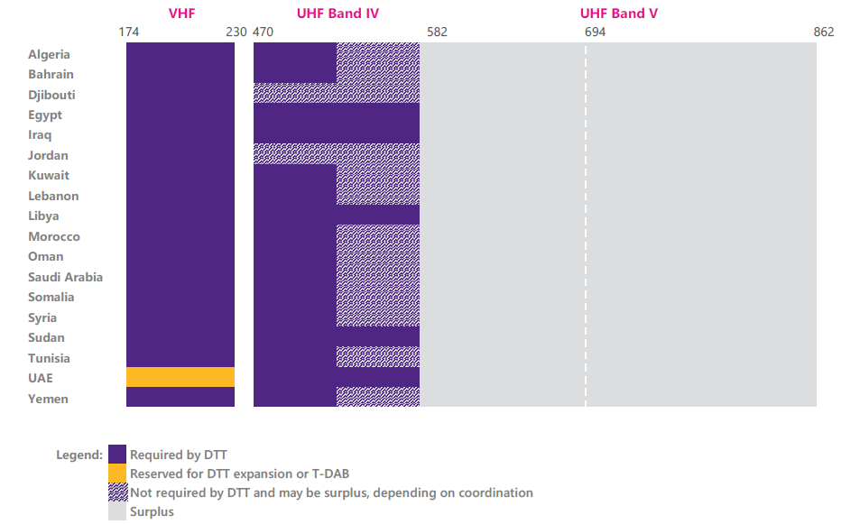

4.1.1 Current developments

4.1.1.1 High Definition (HD) and Ultra High Definition (UHD)
HD is now a widely adopted television standard, utilizing the benefits of digital transmission technology by bringing to the end-user the improvement of picture quality in comparison to the former analogue TV broadcasting systems. It is expected that demand for many services to migrate to HD will continue.
UHD provides further improvement in image quality which is required for large screen TV receivers. It is expected that the foreseen spread of the ultra-large screens and video-walls, providing the “presence effect”, will be an important factor in future media delivery. In that case, broadcasting is an efficient way to deliver UHDTV content to a large number of users simultaneously.

4.1.1.2 Interactive Broadcast Broadband (IBB)
IBB is the technology providing the features of interactive services, as an extension to a linear broadcast service (see Recommendation ITU-R BT.2075 and Report ITU-R BT.2267). While this technology relies on broadband connectivity for bidirectional communication and unicast delivery, the broadcast component of this technology can significantly reduce the load of telecommunication networks and provide services to the users who cannot access them through broadband networks, which is very important for remote or rural areas. The ITU-R Handbook on Digital Terrestrial Television Broadcasting networks and systems implementation (https://www.itu.int/pub/R-HDB-63-2016) provides further information about the additional need of resources for this technology within a broadcast channel.

4.1.1.3 Local, regional and community services
There is an increasing demand for local, regional and community services. Such services, in comparison to country-wide broadcast networks, typically cover a more limited area, and are attractive to audiences because they are able to select content which is more focused on their region.

4.1.1.4 Pay-TV programme services
Pay-TV programmes are delivered in several countries through digital terrestrial television, in particular in Sub-Saharan Africa, where novel Pay-TV offers were developed. Pay-TV offers require a wide choice of programmes to be provided and therefore increase the need for spectrum.

4.1.1.5 [IMT based 5G Broadcast/ LTE-based 5G Terrestrial Broadcast]
The [IMT-based] Broadcast capability (known as 5G Broadcast based on the 3GPP “eMBMS” system) is developed and designed to optimize delivery to, and compatibility with, mobile reception scenarios [, as well as delivery for fixed reception scenario using devices equipped with IMT supporting modems and features.]
5G Broadcast is [part of /based on/ an implementation profile of a subset of] the 3GPP specifications that are referenced in the transposed sets of standards for the terrestrial radio interface of IMT-Advanced (M.2012) and IMT-2020 (M2150).
[The LTE-based 5G Terrestrial Broadcast System is a standalone Broadcasting system offering a downlink-only service intended for direct reception by all members of the general public across the service area, including the capability of free-to-air reception. The system is designed to optimize delivery to, and compatibility with, mobile reception scenarios not excluding delivery for fixed reception.
The complete LTE-based 5G Terrestrial Broadcast System, including the radio and the core parts of the system, is profiled only in ETSI TS 103 720 V1.1.1. To be noted that the radio part of the LTE-based 5G Terrestrial Broadcast System refers to 3GPP specifications which are also referred to in 3GPP 5G-SRIT. /5G Broadcast is the common term used currently for “LTE based 5G terrestrial broadcast” specified in 3GPP and normatively referenced e.g. in ETSI TS 103 720 V1.1.1 (2020-12) and may extend to 5G NR based solutions in the next years.
5G Broadcast is [part of /based on] the 3GPP specifications that are referenced in the transposed sets of standards for the terrestrial radio interface of IMT-Advanced (M.2012) and IMT-2020 (M.2150).]
{Editor's note: There are different views on the terminology of 5G broadcast and potential replacement by IMT broadcast and how to accurately define the term “5G Broadcast” and how to describe the roles of ETSI and 3GPP regarding 5G Broadcast and its link to IMT technology, to be resolved at a future meeting. There are also views that information about broadcast and multicast capabilities in IMT networks may fit in this section or better in the section related to the mobile system.}
[The technology has been used in various trials (see Annex 3 to Report ITU-R M.2373 for some examples). Some broadcasting organizations are deploying or planning to deploy IMT based broadcasting services for public use, while some other broadcasting organizations are now considering whether to deploy systems for public use.
IMT/5G-broadcast may enable more flexible sharing of spectrum resources between broadcast and unicast dynamically based on time, area and user’s demands.
IMT/5G-based Broadcast and other DTTB technologies may need to ensure co-existence with each other. Co-existence between these technologies might require specific network design solutions, interference mitigation techniques, regulatory arrangements or additional standardisation efforts (e.g. an 8 MHz channel bandwidth variant of 5G-Broadcast).
As standards are being extended to include the sub-700 MHz, and manufacturers are implementing the option in handsets, the band 470-694 MHz could become candidate for future deployment of 5G-Broadcast systems. 3GPP Rel-17 RP 210727 specifies the band 470-69x MHz for 5G broadcast with carrier bandwidths of 6, 7 and 8 MHz.
The EBU has published a report entitled “5G for the Distribution of Audio-Visual Media content and services” that includes an analysis of the Spectrum aspects and introduction scenarios in various bands including the sub-700 MHz band.
A report on terrestrial broadcasting and spectrum use in the Arab States showed that actual spectrum requirement will vary by country and that less spectrum requirement needed for traditional DTTB technologies within the 470-694 MHz range.
The GSMA has also released a report entitled ‘The Broadcast Opportunity’ highlighting how IMT/5G-based broadcast technology called ‘Evolved Multicast Broadcast Multimedia Service’ (eMBMS) provide opportunity to wide adoption globally. The rise in IMT network deployments and the adoption of IMT devices has seen a significant growth in terms of public users viewing video content such as live TV, time-shifted TV, on-demand video as well as YouTube videos, noting that a research by Cisco estimated that such usage will represent 75% of all mobile traffic by 2020.
Commercial viability of IMT/5G-Broadcast in the sub-700 MHz spectrum is contingent on the creation of a sufficiently large device and infrastructure ecosystem in this band. This would require that a joint effort be made globally with all stakeholders. Here, the ongoing development in large potential markets such as China and possibly India may deserve specific attention as they might be early adopters of IMT/5G-Broadcast and would influence the developments in other parts of the world.]
According to a recent study on the future use of UHF spectrum in ITU Region 1, there has been a significant increase in the usage of mobile broadband across rural and urban areas in the past 10 years, in developing and developed countries. Much of this mobile traffic is video-based, representing at least 75% of all traffic. Furthermore, use cases for consumers such as VR and proliferation of smartphones and devices, and the growing utilization of high-speed broadband by enterprises for their services, this percentage is expected to increase in the coming years exponentially.
Given the growing demand for broadband high-speed internet access across all demographics and the limited availability of spectrum in the lower bands which have better propagation and coverage characteristics, there is a definite need to examine all existing and potential bands for delivery of video services and to critically analyse which technologies can provide the most spectrally-efficient delivery methods.

4.1.2 Results of the questionnaire
The questions related to future of the DTTB show that investments are foreseen: 52 countries plan the introduction of more programmes; 62 countries anticipate the introduction of enhanced services; 35 countries foresee additional reception modes; 27 countries foresee/already planned to move to new technology.
The table below shows the amount of spectrum in the band 470-960 MHz that Administrations consider will be required for DTTB in the future. 102 Administrations have expressed a clear view on this question. Of those, 12 expressed a requirement for more than 224 MHz, 83 require exactly 224 MHz and 7 Administrations indicate a requirement for less than 224 MHz. A further 4 responses gave no answer or were unclear. [See Table 8 and Figure 9.] [See Figure 1]
Administrations were not specifically asked about the timescales in which their responses would apply, except that they were being asked in order to provide information towards studies on WRC-23 agenda item 1.5. For more information, please see the responses from individual administrations in Report ITU-R BT.2302-1.

]
{Editor's note: Two proposals have been made as to how the results of the questionnaire should be reflected in the text, i.e. either a list of countries supporting each option or a map in new Figure 1. At least one of the options, or a combination of the two, should be retained in this section.}
...

4.2.2 Defining PMSE spectrum demand
Demand for radio spectrum from PMSE applications is time and location specific. It is often incorrectly assumed that PMSE deployments are temporary in nature, when in fact a large proportion of deployments are for long-term use at fixed locations, such as broadcast centres, large studio complexes, or where dense clusters of PMSE venues are found, such as London's West End theatre district. These locations experience very high daily demand for spectrum and are typically not in rural areas.
At other locations, spikes in demand for spectrum occur only for a limited time, such as outdoor music festivals and sporting events like the Tour de France and Formula One Grands Prix. Spectrum demand for PMSE may be both nomadic and geographically defined and/or limited at the same time. In these locations it may be experienced as a high peak over periods of defined and/or limited duration.
The overall trend is one of increasing PMSE demand at the largest events, and for an increasing number of those large events. This trend does not itself create a difficulty because meeting spectrum demand for PMSE applications becomes acute only if the required spectrum is difficult to supply at both the time and location it is needed. However, problems can occur if the temporary events themselves generate extremely high demand for spectrum, or if a temporary event occurs at a location where PMSE use is already high (for example, in proximity to a broadcast studio complex).
In assessing the spectrum requirement for PMSE, it is therefore important to consider that the normal regular demand for spectrum should be distinguished from the peak demand, which may be temporary or geographically limited (see CEPT Report 32 [5]). Overviews of PMSE spectrum usage in some countries are provided in tables below.
Table 1
Number of frequency assignments by band - London
Year | 2014 | 2015 | 2016 | 2017 | 2018
470-790 MHz  (Mics, IEMs, talkback, camera data) | 55 003 | 64 556 | 72 522 | 77 791 | 87 128

Figure 2
Frequencies assigned to wireless microphone equipment per UHF-TV channel during the Tour de France
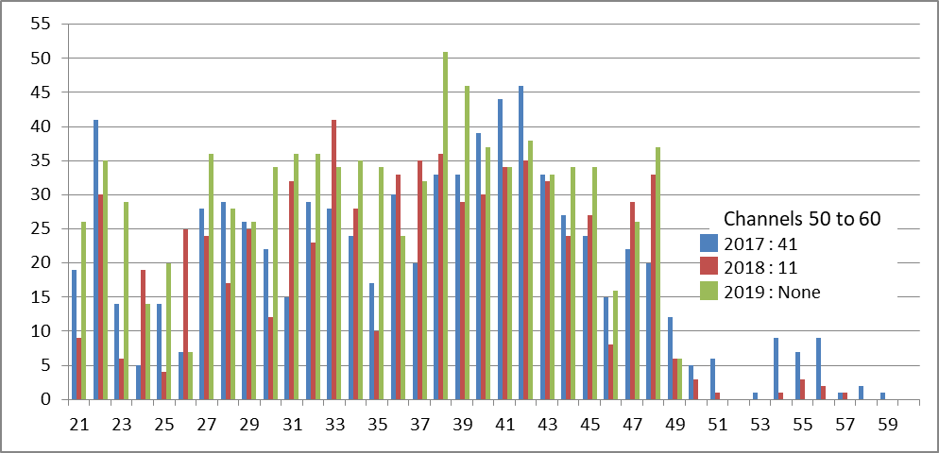
The tables above are a selection from those Administrations which have detailed figures available, most Administrations have a licence-exempt regimes and do not have information: but the tables show a continued increase in numbers year on year.
According to a recent study on the future use of UHF spectrum in ITU Region 1, it was observed that some PMSE use could be shifted to be delivered through IMT systems (e.g. 5G technologies), which can ensure an appropriate quality of service and prioritization due to its network slicing technologies, as well as the low-latency requirements.

________________

ETSI TS 103 720 V1.1.1. https://www.etsi.org/deliver/etsi_ts/103700_103799/103720/01.01.01_60/ts_103720v010101p.pdf.

